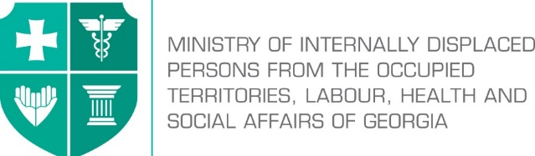

Labour Conditions Inspection Department
Create Together Safe Working Environment!

Annex №7

General Guidance Related to Infection (COVID-19) Caused by Novel Coronavirus (SARS-CoV-2) for Mining Sector

Note: In accordance with Order N281/N of the Minster of Internally Displaced Persons from the Occupied Territories, Labour, Health and Social Affairs of Georgia on “the rule for Examination for Short-term Employment Disability and Issuance of Doctors Note”, the Ministry of Internally Displaced Persons from the Occupied Territories, Labour, Health and Social Affairs of Georgia will issue an equivalent document to the doctors excuse note (Medical Certificate) to persons quarantined in order to prevent the spread of coronavirus. The document will serve as the basis to receive monthly payment and therefore, the working days spend in quarantine or in self-isolation will be legitimate and fully paid to the employees. In order to get the certificate, an interested person has to apply to the Ministry of Internally Displaced Persons from the Occupied Territories, Labour, Health and Social Affairs of Georgia at - info@moh.gov.ge.

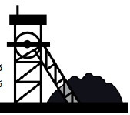The staff must not appear in the workplace if they:
- Left the affected country over the past 14 days;
- Were in close contact with infected person/persons for the past 14 days (they must be self-isolated/quarantined as per the rule);
- Have symptoms of respiratory infection (coughing, temperature, sneezing, difficulty in breathing, general weakness etc.);
- Are among the ones who have high risk of getting infected with COVID – 19 or serious complications: over 70 of age, people suffering from chronicle diseases (cardio-vascular diseases, diabetes, bronchial asthma and other respiratory diseases.
Employer’s Obligations
- Before starting work performance employees health condition must be controlled;
- Whether there are confirmed cases of infection or not, the employer must develop an emergency action plan facilitating the reduction sick leave days and in case there are confirmed cases - prevent its further spread;
- Provide employees with personal protective equipment (respirators, if necessary gloves, face shields and goggles);
- Provide all the employees with information about safe work procedures and prevention of the spread of virus (must be guided by guidelines of National Center for Disease Control and Public Health);
- Place statements about COVID-19 and about preventive measures that have been developed by L.Sakvarelidze National Center for Disease Control and Public Health being under management of the Ministry of Internally Displaced Persons from the Occupied Territories, Labour, Health and Social Affairs of Georgia, so that the employees have opportunity to get familiar with them before starting work performance;
- For the employees, that may perform work remotely, use of such method must be ensured;
- Working time must be limited, employees must work on the basis of rotational shifts;
- No more than ten people must be allowed to work in one space maintaining a safe distance (not less than 2 meters);
- Install disinfection barriers at entrances with appropriate mandatory signs.
- Before starting work performance ensure examination of personnel for virus symptoms by medical staff;
- Place disinfection solutions in the workplace and provide the rules for their collect application;
- Ensure the provision of at least 70% alcohol-based hand rubs to the workplace;
- Provide all the employees with information about preventive procedures;
- Depending on the characteristics of the wok, provide the employees with appropriate personal protective equipment (special clothing, special shoes, helmet, gloves, respirator) establish control on their use;
- Train the employees on proper use of personal protective equipment and hygiene products and their further use/disposal;
- Periodically, several times a day maintain cleaning and disinfecting of used working equipment and work places;
- Dispose of used tissue papers and hygiene products in sealed containers;
- Ensure timely removal of waste by an appropriate person/service;

Employees’ Obligations
Ensuring proper hand hygiene regularly and thoroughly is the best way to be protected from most viruses.

Therefore, it is necessary to take the following measures in the workplace:
- Follow disinfection rules in your workplace;
- Implement the work process in line with the emergency response action plan developed by the employer/Occupational Health and Safety Manager;
- Do not shake hands while greeting and avoid contact (touching etc.);
- It is recommended that no more than ten people must work on one working platform in a confined space maintaining a safety distance (not less than 2 meters);
- Fully apply the PPEs provided by the employer;
- Treat work surfaces and tools used while work performance with disinfection solutions;
- Before and after taking meals, before and after using the restrooms, thoroughly wash your hands with soap and water and dry them well;
- Use spirit based hand rubs if you cannot wash or dry your hands;
- While coughing or sneezing, cover the face with a clean tissue or elbow. Place used disposable tissue in the waste bin;
- Avoid touching your eyes, nose and mouth with your hands;

